

|  |
| --- |
| BAIT 508 Social Media Analytics Project |
|  |
| October 7  MBAN, Sauder School of Business  University of British Columbia  Authored by: Tanishqa Agarwal, Chinmay Jain, Darian Ghorbanin |

Individual Contributions

Each of us coded our version of the different parts of the project. We then got together to discuss and incorporated the best versions of each code to get to the best results.

|  |
| --- |
| Tanishqa AgarwalStudent Number – 24215832Email Id: tanishqaagarwal360@gmail.comSection: BA2 Role: Code for [A], [B], [C], Insights around analysis and Report Formulation |
| Chinmay JainStudent Number – 54565486Email Id: chinmayjain132@gmail.comSection: BA2 Role: Code for [A], [B], [C], [D] and Insights around analysis Darian GhorbanianStudent Number – 79079604Email Id: darian.ghorbanian@gmail.comSection: BA2 Role: Code for [A], [B], [C], [D] and Insights around analysis  Project Overview:  People actively express their opinions in social media platforms such as Twitter, Facebook, Instagram, WeChat, TikTok, etc. As aspiring analytics experts, we want to take this opportunity to use our Python skills to conduct social media analysis.  The platform we have chosen for our analysis is Twitter. Twitter has a 229 million active user base across the globe which provides for a lucrative ground to collect ample data from. Every second, on average, around 6,000 tweets are tweeted on Twitter, corresponding to over 350,000 tweets sent per minute, 500 million tweets per day and around 200 billion tweets per year!  Climate change is one of the most discussed topics of the decade. It is not just an environmental crisis anymore but a social issue affecting all sections of society. Some people think it is a big threat to the planet whereas some people think, it is a hoax. In recent years there has been a lot more awareness on this topic with prominent global leaders/celebrities/organizations taking the fore front on addressing the same via their social media platforms.  Many people take to social media to express their support/opinions on such topics when they are especially trending, but what will be interesting to note is the general perception, activity and sentiment around a social issue such as climate change on any given ‘normal’ day. The aim of this project is to analyze how people’s perceptions towards climate change are using sentiment analysis on Twitter data. |

**Python Libraries Installed**

Below code snippet highlights all libraries installed for the purpose of this project –

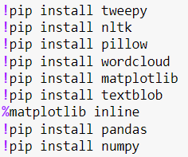

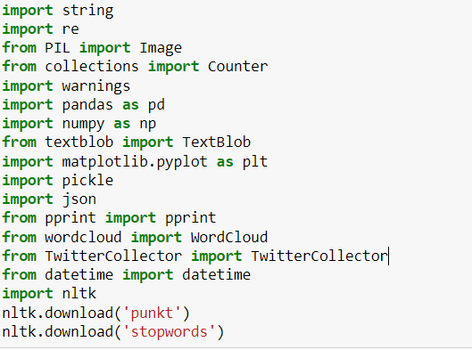

1. **Keyword Selection and Data Collection**
2. Apply for a Twitter Developer’s account

Once we got the account we created a dummy app, and from that app we got the necessary Keys & Tokens which we need for the API.

1. Connecting with Twitter API and extracting the data

After the connection is established, we can query the Twitter API and ask for the data we want.

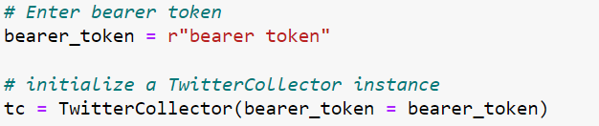

We chose ‘Climate Change’ as our main keyword to pull 10k recent tweets from Twitter. We made sure to filter out any retweets and filtered for tweets only in English. The extracted data was then saved into a json file.

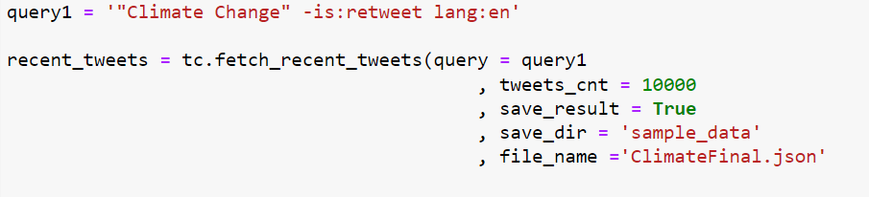

Below is the json file with 10k tweets on climate change



1. Getting the list of unique author IDs

We open the json file created above to do our analysis going forward using the code below -

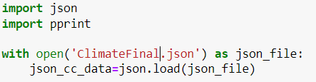

Below code helps us get the list of unique author IDs

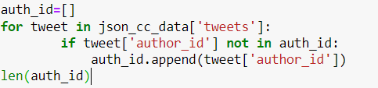

This gives us a list of **8258** unique author ids from the 10k tweets collected

1. Collecting author information for the collected author IDs

Because there is limitation in fetching huge amounts of data at a time, we are fetching author information for 300 authors at a time. Snippet below –

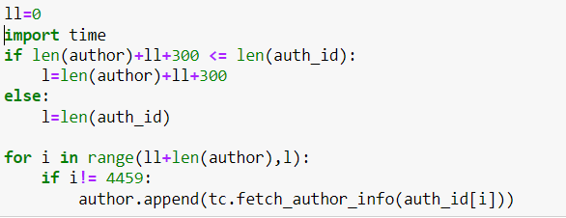

We then take only the relevant columns from the author data and create a pandas data frame for ease of analysis and then finally save it into a csv file.

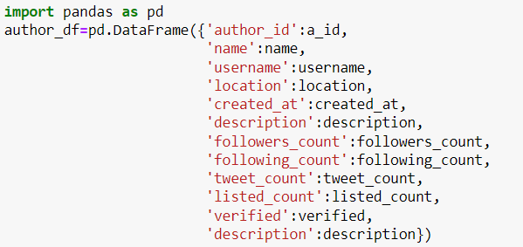

Below is the final csv file that contains all relevant author information



1. **Preliminary Analysis**
2. 10 Most Popular words with and without stop words

* Without stopwords:

Below are the top 10 most popular words from the twitter data set extracted (recent_tweets)

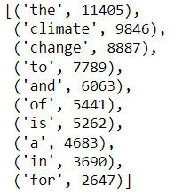

* With stopwords:

We used the list below to add further stopwords into the already existing stopword list imported from nltk library

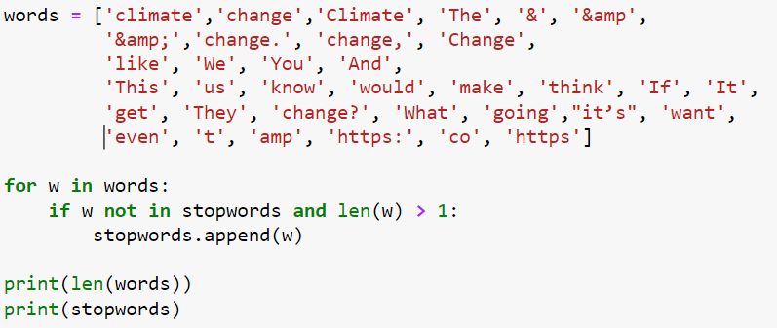

Below are the top 10 most popular words from the twitter data set extracted (recent_tweets)

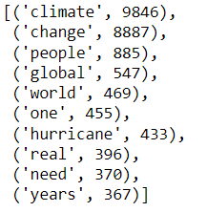

1. 10 Most Popular word hashtags

Below are the 10 most popular hashtags from the twitter data extracted(recent_tweets)

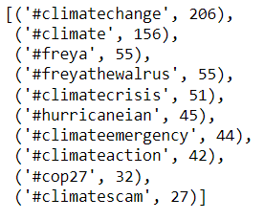

Insight: It is interesting to note that Hurricane Ian originated on 19th Sept and 15 days later, is still a trending hashtag within climate change.

Also, interesting are the hashtags surrounding Freya the Walrus. She was euthanized mid-August, however there is still considerable chatter around the topic within climate change.

1. 10 Most frequently mentioned usernames

Below are the 10 most frequently mentioned usernames from the twitter data extracted(recent_tweets)

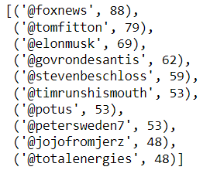

Insight: The mix includes 1 news channel, 8 influential twitter personalities, and 1 company that produces & markets energies on a global scale.

1. 3 Most common sources of tweet

Below are the 3 most common sources of tweet from the twitter data set extracted(recent_tweets)

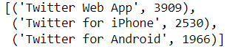

**Insight:** The general assumption is that people mainly use their phones to access social media especially when it comes to quick posts such as twitter, however the twitter web app showing up as the top source of tweet makes for an interesting insight.

1. Time trend of tweet counts per minute of the hour

The below trend line highlights the number of tweets posted at each minute of the hour across all hours in a day

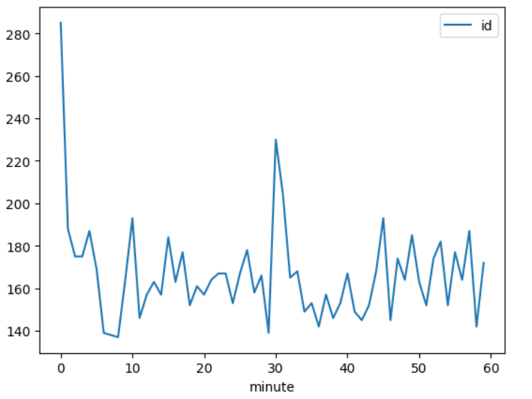

**Insight:** There are prominent spikes at the 0th minute, i.e. (11:00 AM, 12:00 PM, etc.) and the 30th minute, i.e. (11:30 AM, 12:30 PM, etc.)

The below trend highlights the number of tweets posted at each hour of the day

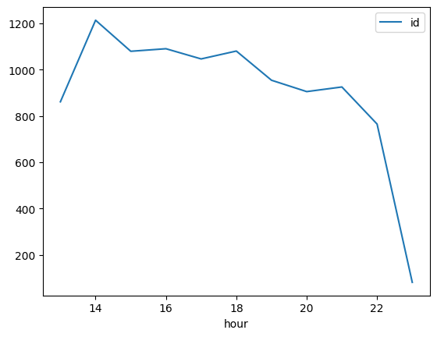

**Insight:** We can see that people mostly tweet in the afternoon and as the day progresses the no. of tweets reduces. Of the 10,000 tweets we collected 12% of the tweets were made at 2 pm

1. 3 Most influential tweets

A tweet’s influence score is the sum of “quote_count”, “reply_count”, “retweet_count”, “like_count”

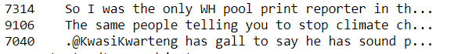

1. 3 Most vocal authors

We chose the authors with the maximum tweets within data collected (recent_tweets) to come up with the top 3 most vocal authors

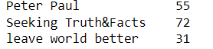

1. 3 Most Influential authors

A user’s influence score is the sum of “followers_count”, “following_count”, “listed_count”. “tweet_count” in the author data

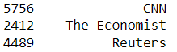

**Insight:** The top 3 most influential authors from our dataset collected are all prominent news channels

1. **Word Cloud**

We have used the following functions to enhance our word cloud:

* Mask, to change shape of default word cloud to custom shape as per image loaded
* ‘Scale’ of 3, which makes the computation faster for larger word cloud images
* ‘Colormap’ is set to ‘Blues’ to better suit to our image shape and selected keyword for the analysis
* Collocations are set to False to give a fuller word cloud
* Max word is set to 125 to avoid clutter in the cloud
* We replaced certain words/punctuations from our data and then added certain redundant words to the stopword list to create a clean word cloud with relevant words

Code Snippet –

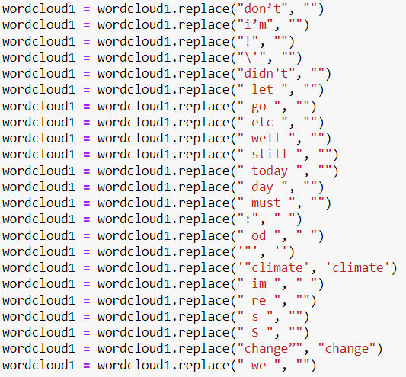

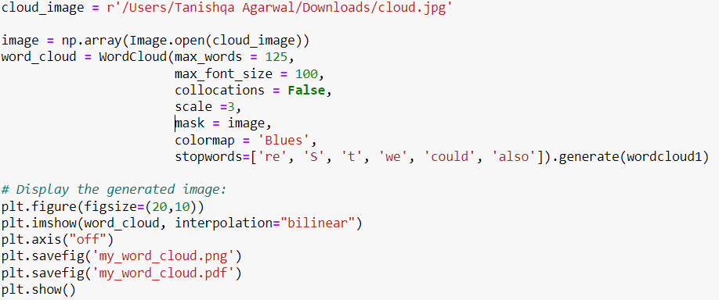

Below word cloud highlights the most significant 125 words from our twitter data source

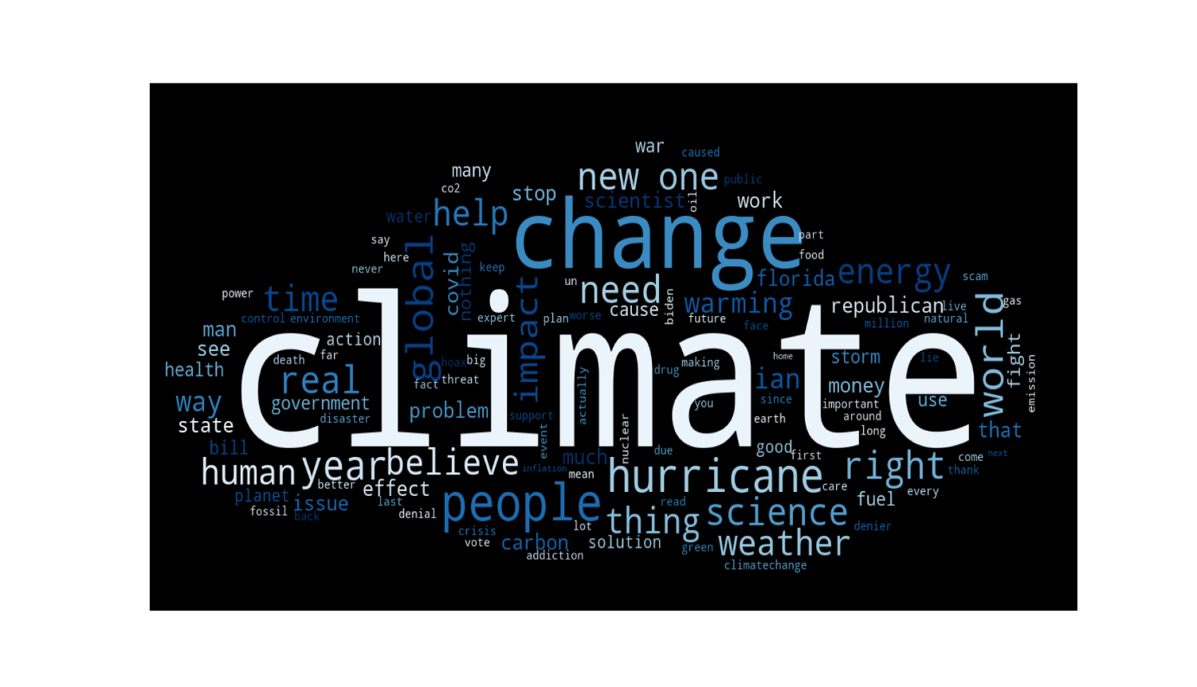

1. **Sentiment Analysis**
2. Average Polarity and Subjectivity scores

We used the TextBlob python library to run our sentiment analysis on the data collected. TextBlob is a python library for Natural Language Processing (NLP). TextBlob actively uses Natural Language Tool Kit (NLTK) to achieve its tasks.

Polarity lies between [-1,1]. A polarity of -1 indicates a negative sentiment whereas a +1 indicates a positive sentiment.

Subjectivity lies between [0,1]. Subjectivity quantifies the amount of personal opinion and factual information contained in the text.

Code Snippet –

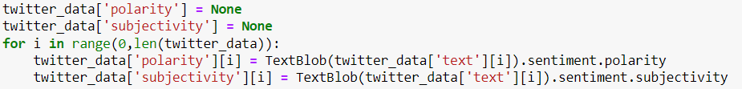

Below is the avg. polarity and subjectivity of our dataset(recent_tweets) respectively-



**Insight:** The avg. polarity score of 0.07 indicates a somewhat neutral sentiment around climate change within the data set we collected, i.e., neither positive nor negative.

The avg. subjectivity score of 0.39 indicates that the data contains relatively higher personal opinion as compared to factual information.

1. Polarity and Subjectivity Score Distributions

Polarity Scores Histogram –

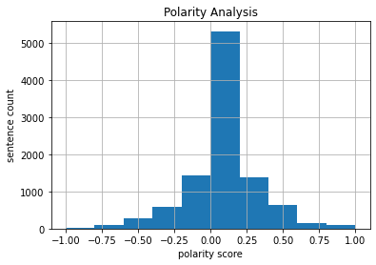

Subjectivity Scores Histogram –

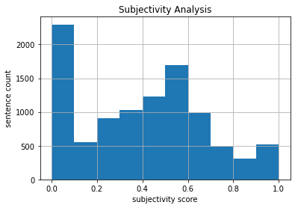

**Insight:** The polarity score distribution ties back with our mean score indicating that the number isn’t skewed, and the general sentiment is neutral around climate change

The subjectivity score distribution shows a peak between 0.0 & 0.1 indicating that ~2.2 k tweets (i.e., 25% of the tweets collected) are purely factual. However due to a wider distribution of tweets between 0.4 & 0.6, this insight gets masked in the mean subjectivity score despite accounting for 25% of the data.

1. Tweets with Most Positive & Negative Polarity

* Top 3 tweets with Highest Polarity

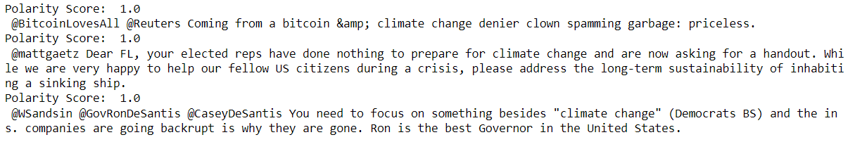

**Insight:** Reading the tweets, we can infer that the authors for their respective tweets are actually NOT happy about climate change, however the tweet uses certain very positive words that marks these as tweets with polarity 1

* Top 3 tweets with Highest Polarity

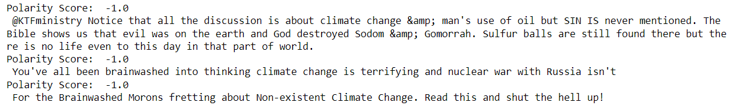

**Insight:** Reading the tweets, we can infer that the authors are not very happy and expressing their negative sentiment about the topic is evident from both the polarity score and the text of the tweet as well.

1. **Insights**

We did some additional analysis on the data that was collected to better understand the data and draw some interesting insights from it.

Verified & Unverified Authors

93.6% of the authors, i.e., 7729 of the authors are unverified (without a blue tick on twitter) and 6.4%, i.e., 528 are verified authors (with a blue tick on twitter). What will be interesting to note are the polarity and subjectivity scores associated with each group.

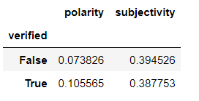

The avg. subjectivity score is pretty similar for both verified and unverified users, however the avg. polarity score sees some difference, indicating verified users in the dataset tend to be slightly more mindful/positive about their tweets compared to unverified users.

This can be further corroborated using the polarity score histograms for verified and unverified users as below –

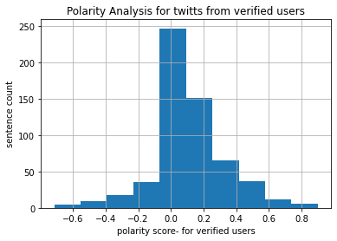

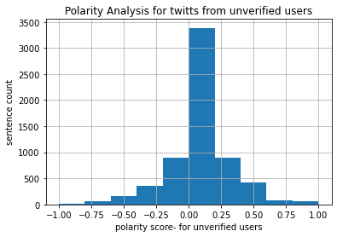

Broader Social Media Project

We can find insights about the effects of social media on some KPIs inside a corporate. In other words, how different social media activities regarding the specific keywords is related to different corporate outputs including sales, marketing, finance, and HR indexes.

For example, the relationship between the social media activities and the clicks on a call-to-action in our website is one of the invaluable insights. This analysis can go larger that includes the effect of the number of the clicks, then lead conversions, and finally the effect on the final revenue increase.

Regarding HR issues, we may be able to find employees’ satisfaction and even predict the probability that they would resign or not in the years to come based on social media analysis.

Or we can find a key word related to the industry of that corporate and find out how social media activities about that keyword, would affect the productivity of employees. For example, how negative news are affecting staff.